H.T No
Regulations:
A18

Sreenidhi Institute of Science and Technology
(An Autonomous Institution)
Code No: 7K717 Date: 19-Jan-2023 (FN)

B.Tech IV-Year I- Semester External Examination, January-2023 (Regular & Supplementary)
FINITE ELEMENT METHOD FOR CIVIL ENGINEERS (CIVIL)

Time: 3 Hours Max.Marks:70

Note: a) No additional answer sheets will be provided.
b) All sub-parts of a question must be answered at one place only, otherwise it will not be valued.
c) Missing data can be assumed suitably.
Bloom's Cognitive Levels of Learning (BCLL)

Remember | L1 | Apply | L3 | Evaluate | L5
Understand | L2 | Analyze | L4 | Create | L6

Part - A Max.Marks:20

Answer all QUESTIONS.
 |  | BCLL | CO(s) | Marks
1 | Define plane stress with a suitable example. | L1 | CO1 | [2M]
2 | What are the properties of shape functions? | L2 | CO2 | [2M]
3 | Explain the local coordinate system for a CST element. | L1 | CO3 | [2M]
4 | Explain the isoparametric elements and their advantages. | L2 | CO4 | [2M]
5 | What is static condensation? | L2 | CO5 | [2M]
6 | What is the significance of the post processing of the results? | L1 | CO6 | [2M]
7 | What is Raleigh-Ritz method? | L3 | CO1 | [2M]
8 | Distinguish between 1D bar element and 1D beam element. | L2 | CO2 | [2M]
9 | Explain one point Gaussian Quadrature. | L2 | CO5 | [2M]
10 | What are the properties of stiffness matrix? | L1 | CO2 | [2M]

Part – B Max.Marks:50
ANSWER ANY FIVE QUESTIONS. EACH QUESTION CARRIES 10 MARKS.

 |  |  | BCLL | CO(s) | Marks
11. |  | A simply supported beam of span L, young’s modulus, E moment of inertia I is subjected to a uniformly distributed load of P/unit length. Determine the deflection W at the mid span. | L4 | CO1 | [10M]
12. |  | For the stepped bar shown in the figure below, determine the nodal displacements, element stress and support reactions. Take E = 210 GPa, A1 = 200 mm², A2 = 100 mm² .  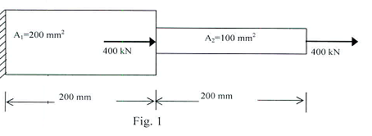 | L4 | CO2 | [10M]
13. |  | For the point P in element shown in below fig. compute the local coordinates.  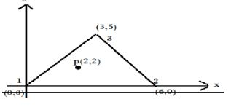 | L6 | CO3 | [10M]
14. |  | For the element shown in the fig compute Jacobian matrix and strain displacement matrix.  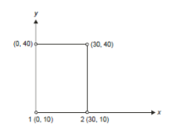 | L4 | CO4 | [10M]
15. |  | Solve for U3, U4 from the below equation using static condensation technique  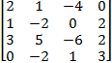 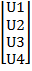 = | L3 | CO5 | [10M]
16. |  | Explain the procedure for solving a below beam problem using ANSYS software. Take cross section as 200mm circular.  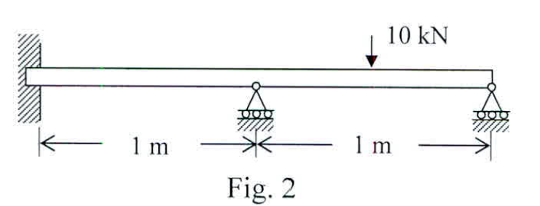 | L2 | CO6 | [10M]
17. | a) | List and briefly describe the general steps of the finite element method. | L2 | CO1 | [4M]
 | b) | Draw the Lagrange shape functions of the quadratic element for 1-D bar. | L3 | CO2 | [3M]
 | c) | Give the expression for the Jacobian of the triangular CST element. | L3 | CO3 | [3M]
18. | a) | Obtain the shape functions of a four noded quadrilateral element | L5 | CO4 | [5M]
 | b) | Drive the parameters for one point Gaussin quadrature | L5 | CO5 | [5M]

-- 00 -- 00 –

